THEORY QUESTIONS
1.
(a)

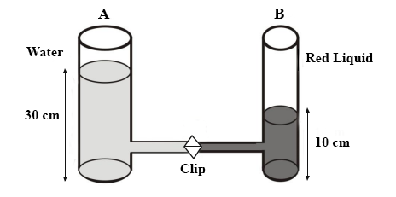
In an experiment, as in the set-up above, two glass containers A and B of different sizes are joined together with a tube and clipped.
Water is poured into container A to a height of 30 cm and a red liquid is poured into B to a height of 10 cm. The clip is then removed so that the liquids join together.
(i)

State two observations that will be made immediately the clip is removed.
(ii)

Explain the observations in (i).
(iii)

What two observations will be made after a long time? Explain.
(b)

The set-up below is used in the preparation of ammonia gas in the laboratory
Study it and answer the questions that follow.
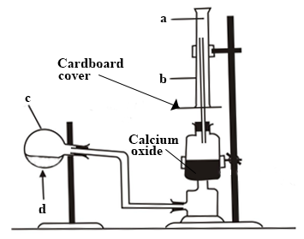
(i)

Name the parts labelled a, b and c
(ii)

What is the meaning of the arrow sign d?
(iii)

What is the function of the calcium oxide?
(iv)

Why has c been tilted downwards?
(v)

State the method by which the gas is collected.
(vi)

How will you test for the gas?
(vii)

Give the names and the chemical formulae of the compounds that form the content of c.
(c)

In an experiment, a leaf that is partly green and partly yellow is plucked from a tree and the leaf is
I boiled for a minute,
II dipped in warm alcohol,
III washed in cold water,
IV dipped in iodine solution.
One part of the leaf turns blue-black after the dipping in iodine solution while the other part remains unchanged.
(i)

Explain why each of the processes I, II and III
(ii)

Which part of the leaf turns blue-black? Explain.
(iii)

Why does the other part of the leaf not change colour?
(iv)

What conclusion can you draw from the experiment?

2.
(a)

(i)

State the difference between an opaque object and a translucent object
(ii)

Give one example each of an opaque and a translucent material.
(b)

(i)

What is the importance of seed dispersal?
(ii)

Name two types of fruits and state their mode of dispersal.
(c)

(i)

What is recycling?
(ii)

Give two advantages of recycling of materials.
(iii)

List three recycled products in Ghana.

3.
(a)

(i)

Explain the term bedwetting?
(ii)

State two diseases that may result from bedwetting.
(b)

(i)

State the difference between hard water and impure water.
(ii)

Give the stages involved in the treatment of water for a community.
(c)

A piece of stone has a mass of 36.0 g. When it is put into water in a glass container, the level of water rises from 60.0 cm³ to 90.0 cm³.
(i)

Calculate the density of the stone.
(ii)

Explain what will be observed when the stone is put into another liquid of density 1.4 gcm⁻³?

4.
(a)

(i)

What is an echo?
(ii)

State two uses of echoes.
(b)

(i)

State three diseases that affect the respiratory system of human.
(ii)

Name one method each by which the diseases you have named can be prevented.
(c)

(i)

What is biotechnology?
(ii)

List three products that are obtained from biotechnology.

5.
(a)

(i)

Define pressure
(ii)

State three applications of pressure in everyday life
(b)

State four functions of the liver in digestion.
(c)

(i)

What is a compound?
(ii)

Give two properties of a compound
(iii)

Write down the name and the chemical formula of the compound formed between the following elements:
(α)

hydrogen and chlorine
(β)

magnesium and oxygen

